PROJECT SCHOOL

at

KESHAV MEMORIAL ENGINEERING COLLEGE

Submitted in partial fulfilment of the requirements for the award of Bachelor of Engineering Degree in Computer Science and Engineering

By

245522733034 - M ABHISHEK

245522733022 - JAKKU MEGHANA

245522733021 - GOTTE NAMRATHA YADAV

245522733033 - LOKYAAN ABINETRE KOTI

245522733046 - PENDYALA MANIKANTA

245522733303 - SAMPANGI SHIVA KUMAR



DEPARTMENT OF COMPUTER SCIENCE AND ENGINEERING

PROJECT SCHOOL

KESHAV MEMORIAL ENGINEERING COLLEGE

FEBRUARY 2024

USER MANUAL

# INTRODUCTION

Welcome to the user manual for the Smart Parking App! This comprehensive guide is designed to provide you with all the information you need to make the most out of our innovative parking solution. Whether you're a first-time user or a seasoned pro, this manual will walk you through the app's features, functionalities, and best practices for a seamless parking experience.

The Smart Parking App is your go-to tool for convenient and hassle-free parking. Say goodbye to circling crowded lots and hunting for elusive parking spots. With our app, you can easily reserve parking spaces in advance, receive real-time updates on availability, and seamlessly access your reserved spot upon arrival.

In this manual, you'll find step-by-step instructions on how to get started with the app, book parking spaces, manage reservations, and navigate its various features. Additionally, we'll provide tips and tricks for optimizing your parking experience and troubleshooting any issues you may encounter along the way.

Whether you're a busy commuter, a frequent traveller, or simply someone looking for stress-free parking solutions, the Smart Parking App is here to make your life easier. We're committed to providing you with a user-friendly, reliable, and efficient parking experience, and this manual is your ultimate companion in unlocking the full potential of our app.

Thank you for choosing the Smart Parking App. Let's get started on your journey to smarter parking!

# How to download the application

Park Hub application can be downloaded through the following steps:

1. Open Google Play store.
2. Click on the Google Play text at the top and enter the text "Park Hub" in the search bar.

Click on the Park Hub app icon from the search result. Now below page will open

which asks to install the application. Click on the "INSTALL" button to install the application.

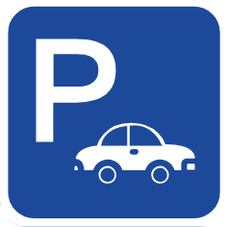

# Creating an account

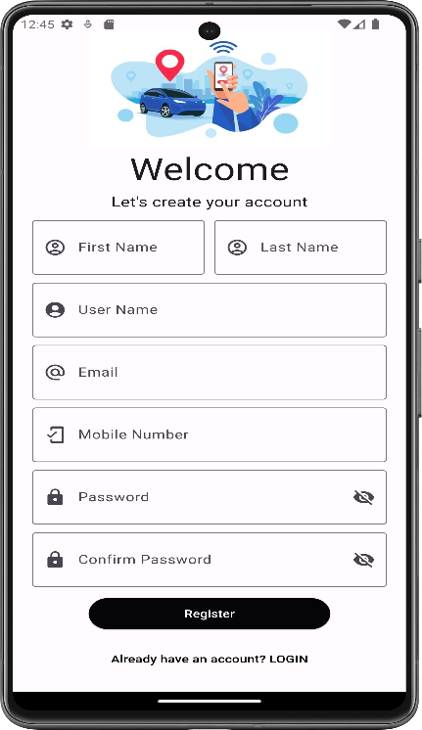

1. After loading of the splash screen this account screen will be visible.

2. Enter your First Name, Last Name, User Name, valid Email, mobile number.

1. Enter the password and confirm the password. The eye icon at the end is used to hide or show the password.
2. After confirmation of the password click the register button. Then a pop-up shows that verification email is sent to your mail.
3. Verify the email. Then you will be directed towards the sign in screen.

Note: If you already have an account then you can directly click on the Already have an account? LOGIN button, then you will directly get navigated to sign in screen.

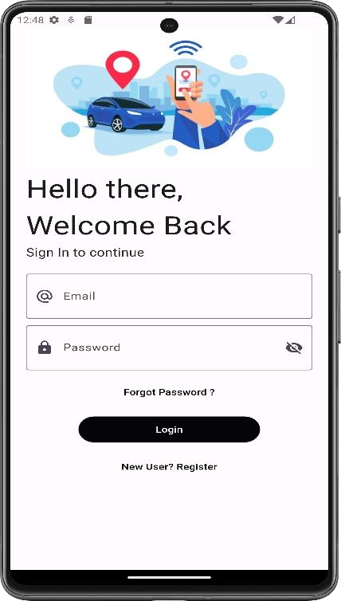 6. Now type the email that you registered with.

7. Enter the password.

If you forgot the password then you can reset it with the help of Forgot Password? Button.

8. Then click on login button , you will be directed towards the homepage.

# Home page

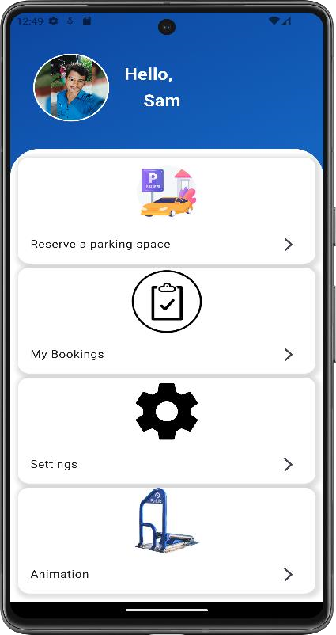 In the home your username will be visible and there will be four options available. They are:

1. Reserve a parking space
2. My bookings

3. Settings

4. Animation

# Reserve a Parking space

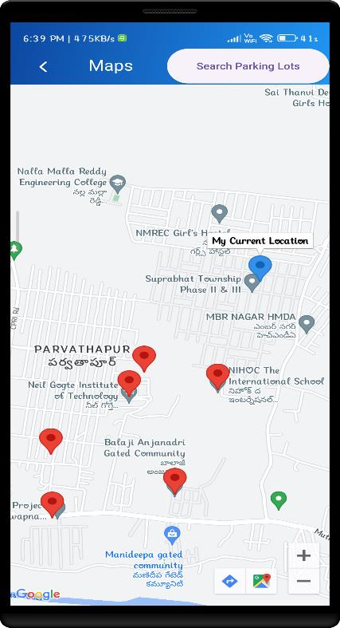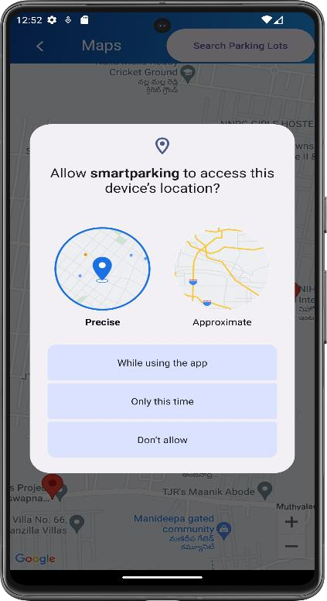

1. After clicking the Reserve a parking space you will be directed towards the Google maps screen.
2. Then it asks to access the device’s location. According to your requirements click on either of the three options provided.
3. Then you can see the parking lots marked in red and your current location marked in blue.
4. Select a parking lot by clicking on the red pin.

1. 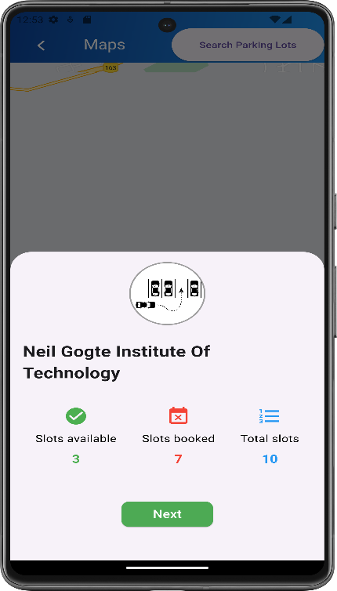After selecting a parking lot, there will be pop-up displaying the: Total slots

Slots available

Slots booked

1. If there are no slots available then you can select a different parking lot.
2. Then click the Next button and you will get navigated to the date and time screen.

# Date and Time screen

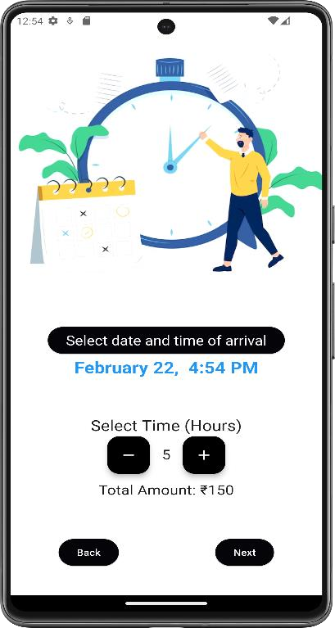

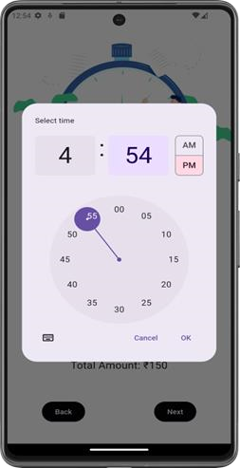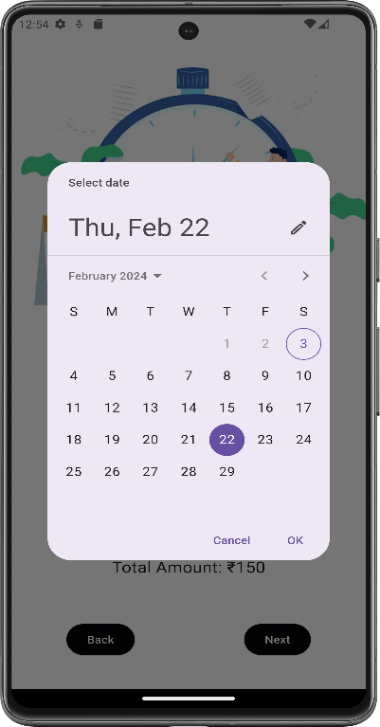

1. By clicking on the Select date and time of arrival but ,first a calendar is shown , select the required date and click on ok.
2. Then a clock is shown, select the time you want to arrive to our parking lot and click on ok.
3. Then by clicking on + or – you select the number of hours you want to book the slot.
4. According to number of hours you booked the slot the amount will be shown.
5. If you want to proceed to next screen click on next button or else to go to the previous screen click on back button.
6. After clicking on the next button you will be directed to the Vehicle Details screen.

# Vehicle Details

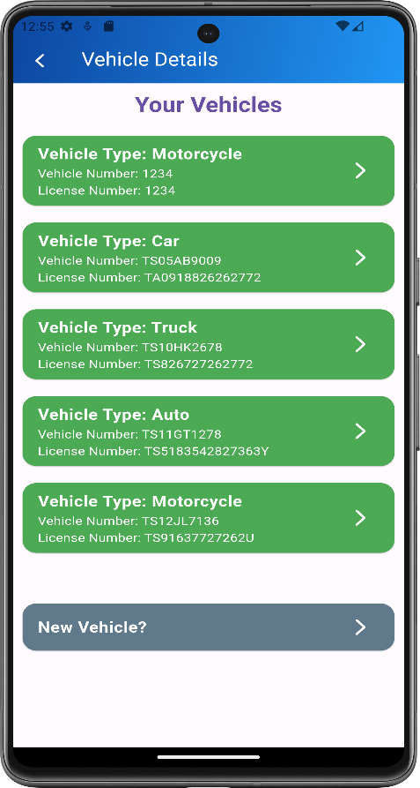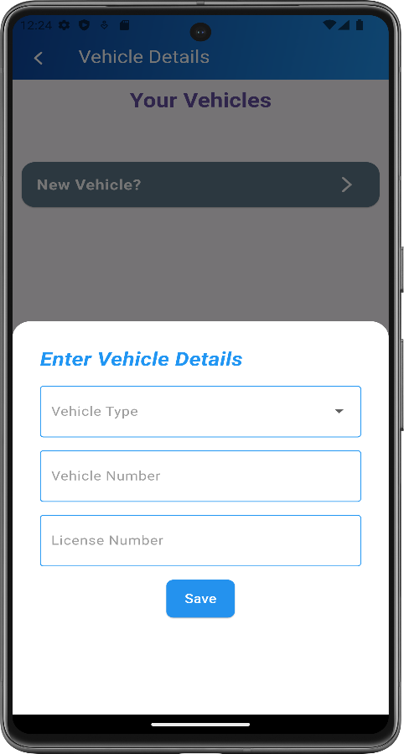

1. In the vehicle details screen you can see your saved vehicles. If you are a new user then you can click the New Vehicle? Button.

1. Then enter the details of your vehicle and click on the save button.

3.Select the vehicle that you want to park by clicking on that.

4.Then you will get navigated to the slot selection page.

# Slot Selection

1. 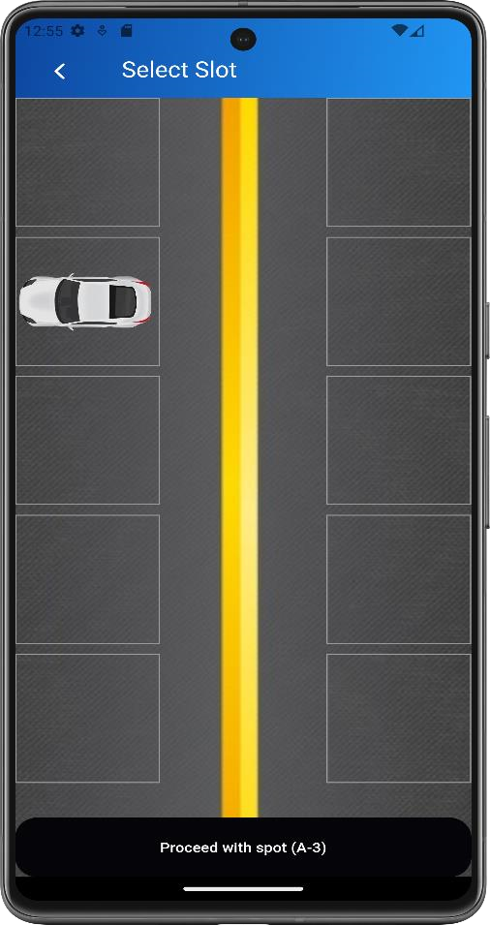Select the slot where you want to park your vehicle.
2. You will be only able to select the slots which are vacant.
3. Then to do the payment click on the proceed button.

# Payments and Invoice

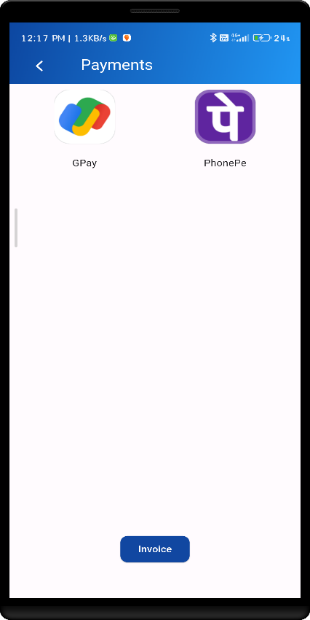 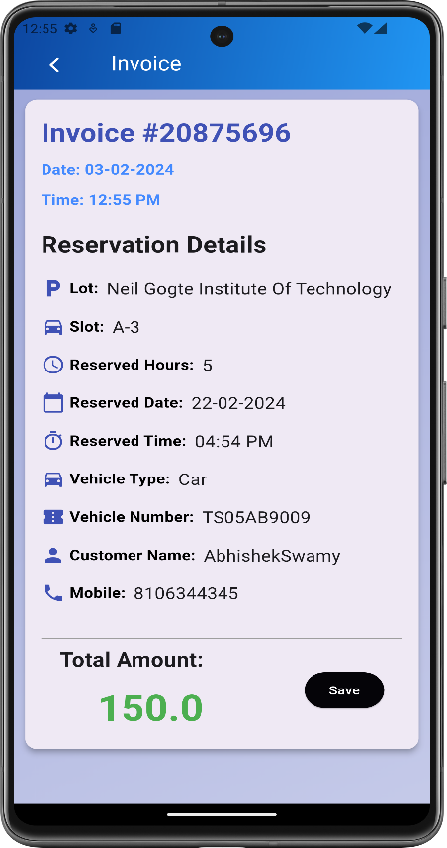

1.In the payment screen there will be online payment apps visible that are already registered on your phone.

For example, if you have Google Pay and PhonePe on your mobile then those apps will be visible on the screen. You can do the payment by clicking on either one of them.

1. To see the invoice details, click on the invoice button.
2. You can see your reservation details like lot, slot, reserved hours, reserved date and time, vehicle type, vehicle number, customer name and mobile number and the total amount.
3. Click on the save button so that all your bookings will be saved and visible in the My Bookings section in the home page.

# Settings

1. 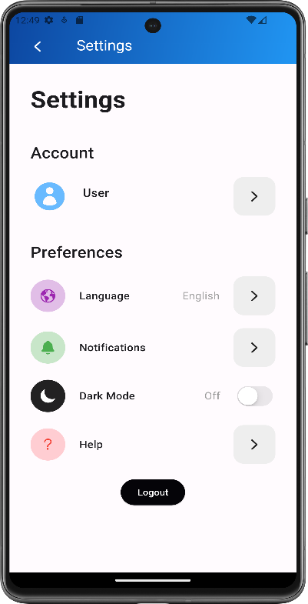In the home screen when you click on settings button this page will be visible. It contains options like:

Account

Preferences

Logout

1. In the preferences section you can set the Language, Notification status, Dark mode. For any queries you can click on the Help button.
2. By clicking on the logout button you will get logged out from your account. Then to access your account again you can log in by clicking on the Already have an account? Login button in the register screen.

# Profile

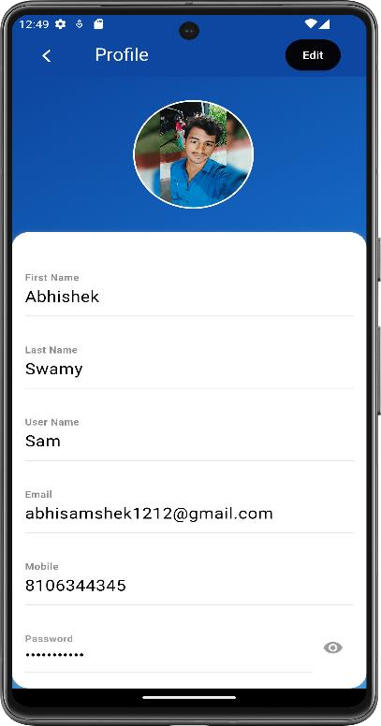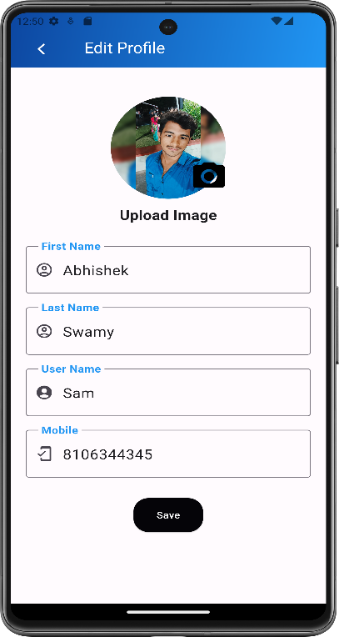

1. After clicking on the user button, profile page will be visible which contains all the details with which you registered.
2. To modify the details you can click on the Edit button in the top right corner.
3. To upload a profile picture click on the camera icon. You can select a picture from the gallery.
4. Enter the details. Then click on the save button.

# My Bookings

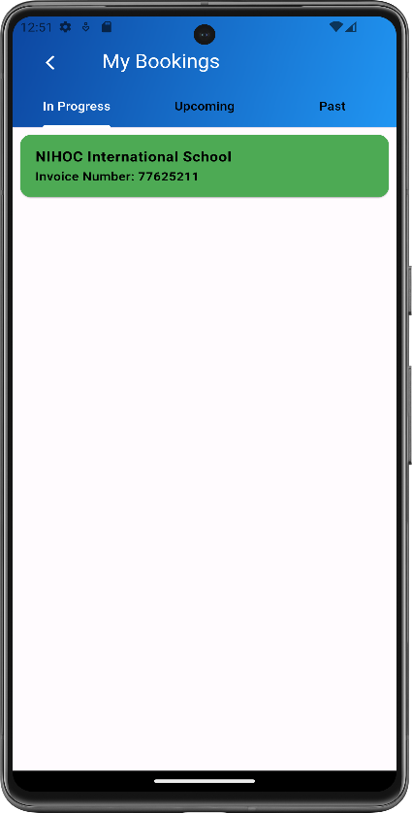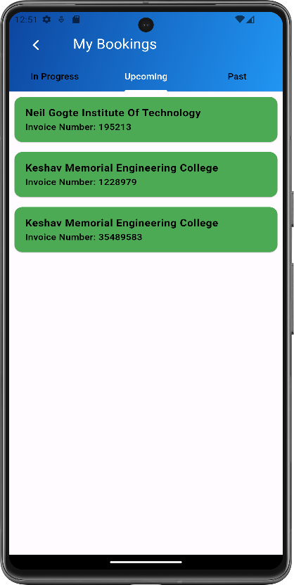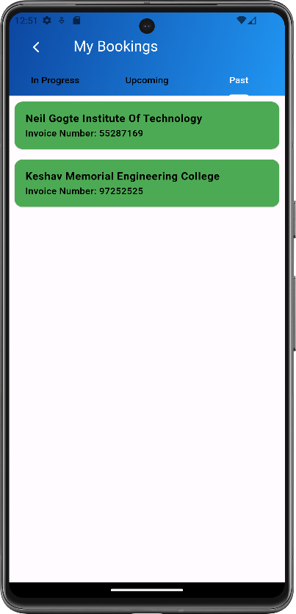

1. When you click on the My Bookings button on the home screen you will be navigated here.
2. This contains three sections:

In Progress: It contains the details of your bookings which are in progress Upcoming: It contains the details of your upcoming bookings.

Past: It contains the details of your past bookings.

# Animation

1. 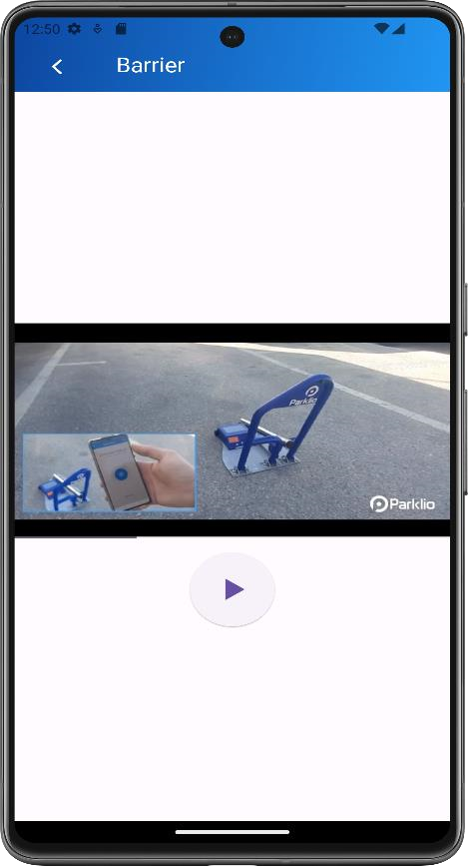When you click on the Animation button in the home screen you will get to the barrier screen
2. When you play the video you get to see how the parking barrier works.

# CONCLUSION

In conclusion, this user manual serves as a comprehensive guide to help you effectively utilize the Smart Parking App and optimize your parking experience. By following the instructions provided in this manual, you can easily navigate through the app's features, make reservations, manage bookings, and access your reserved parking spaces with ease.

We are committed to providing you with a seamless and convenient parking solution, and this manual is designed to support you every step of the way. Whether you're a new user just getting started or a seasoned user looking to make the most out of the app's features, we hope that this guide has provided you with the information you need to succeed.

If you have any questions, encounter any issues, or require assistance while using the Smart Parking App, our dedicated support team is here to help. Feel free to reach out to us through the provided contact channels, and we'll be happy to assist you.

Thank you for choosing the Smart Parking App. We appreciate your trust in us and look forward to providing you with a convenient and stress-free parking experience. Happy parking!